Object Scan Script Tutorial

Firstly i created the script for scanning assets/objects. The script is shown below in a form of a screenshot.

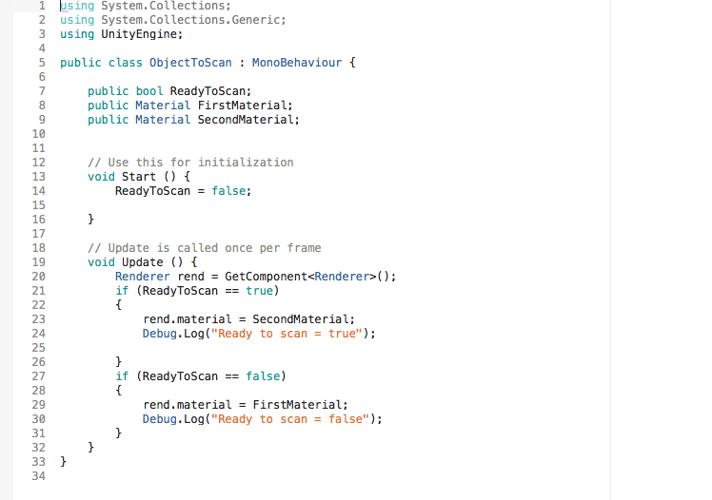

You created two public materials the 1st public material is the original colour of the object/asset. The 2nd material is the colour the object/asset will turn when the player is in range to scan the object.

Under void start you added a ready to scan part and started it of with false so the object would not change colour as if it was being scanned. So it would stay the same colour as the person made it.

If the player scanned the object the object would change colour as shown in the coding in line 23 and 24 as it would render the second material if ready to scan was true. When the player get further away from the object ready to scan will equal false which will result in the obect returning to its original colour

After finishing the script you add it to the game object you want to be scanned. You do this by adding a component to the object and add script. Also add a meshcollider